ЛАБОРАТОРНАЯ РАБОТА Вариант 10.
Проектирование БД приёмного покоя больницы
1. Модель в третьей нормальной форме (3NF)
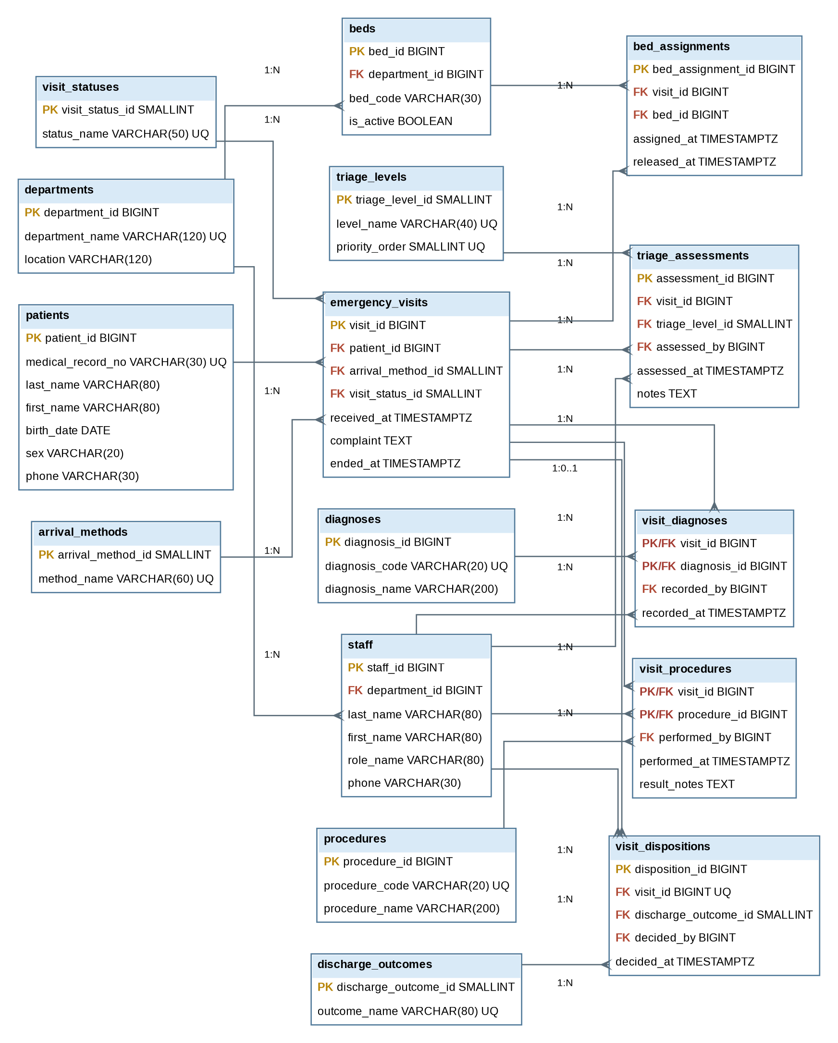

Состав модели 3NF
В модели 16 таблиц: patients, emergency_visits, arrival_methods, visit_statuses, triage_assessments, triage_levels, staff, departments, visit_diagnoses, diagnoses, visit_procedures, procedures, beds, bed_assignments, visit_dispositions, discharge_outcomes.

SQL-код создания схемы 3NF

CREATE TABLE departments (
department_id BIGINT GENERATED ALWAYS AS IDENTITY PRIMARY KEY,
department_name VARCHAR(120) NOT NULL UNIQUE,
location VARCHAR(120)
);

CREATE TABLE staff (
staff_id BIGINT GENERATED ALWAYS AS IDENTITY PRIMARY KEY,
department_id BIGINT NOT NULL REFERENCES departments(department_id),
last_name VARCHAR(80) NOT NULL,
first_name VARCHAR(80) NOT NULL,
middle_name VARCHAR(80),
role_name VARCHAR(80) NOT NULL,
phone VARCHAR(30)
);

CREATE TABLE patients (
patient_id BIGINT GENERATED ALWAYS AS IDENTITY PRIMARY KEY,
medical_record_no VARCHAR(30) NOT NULL UNIQUE,
last_name VARCHAR(80) NOT NULL,
first_name VARCHAR(80) NOT NULL,
middle_name VARCHAR(80),
birth_date DATE,
sex VARCHAR(20),
phone VARCHAR(30)
);

CREATE TABLE triage_levels (
triage_level_id SMALLINT GENERATED ALWAYS AS IDENTITY PRIMARY KEY,
level_name VARCHAR(40) NOT NULL UNIQUE,
priority_order SMALLINT NOT NULL UNIQUE CHECK (priority_order > 0),
description TEXT
);

CREATE TABLE arrival_methods (
arrival_method_id SMALLINT GENERATED ALWAYS AS IDENTITY PRIMARY KEY,
method_name VARCHAR(60) NOT NULL UNIQUE
);

CREATE TABLE visit_statuses (
visit_status_id SMALLINT GENERATED ALWAYS AS IDENTITY PRIMARY KEY,
status_name VARCHAR(50) NOT NULL UNIQUE
);

CREATE TABLE discharge_outcomes (
discharge_outcome_id SMALLINT GENERATED ALWAYS AS IDENTITY PRIMARY KEY,
outcome_name VARCHAR(80) NOT NULL UNIQUE
);

CREATE TABLE emergency_visits (
visit_id BIGINT GENERATED ALWAYS AS IDENTITY PRIMARY KEY,
patient_id BIGINT NOT NULL REFERENCES patients(patient_id),
arrival_method_id SMALLINT NOT NULL REFERENCES arrival_methods(arrival_method_id),
visit_status_id SMALLINT NOT NULL REFERENCES visit_statuses(visit_status_id),
received_at TIMESTAMPTZ NOT NULL,
complaint TEXT NOT NULL,
ended_at TIMESTAMPTZ,
CHECK (ended_at IS NULL OR ended_at >= received_at)
);

CREATE TABLE triage_assessments (
assessment_id BIGINT GENERATED ALWAYS AS IDENTITY PRIMARY KEY,
visit_id BIGINT NOT NULL REFERENCES emergency_visits(visit_id) ON DELETE CASCADE,
triage_level_id SMALLINT NOT NULL REFERENCES triage_levels(triage_level_id),
assessed_by BIGINT NOT NULL REFERENCES staff(staff_id),
assessed_at TIMESTAMPTZ NOT NULL,
notes TEXT
);

CREATE TABLE diagnoses (
diagnosis_id BIGINT GENERATED ALWAYS AS IDENTITY PRIMARY KEY,
diagnosis_code VARCHAR(20) NOT NULL UNIQUE,
diagnosis_name VARCHAR(200) NOT NULL
);

CREATE TABLE visit_diagnoses (
visit_id BIGINT NOT NULL REFERENCES emergency_visits(visit_id) ON DELETE CASCADE,
diagnosis_id BIGINT NOT NULL REFERENCES diagnoses(diagnosis_id),
is_primary BOOLEAN NOT NULL DEFAULT FALSE,
recorded_by BIGINT NOT NULL REFERENCES staff(staff_id),
recorded_at TIMESTAMPTZ NOT NULL DEFAULT CURRENT_TIMESTAMP,
PRIMARY KEY (visit_id, diagnosis_id)
);

CREATE TABLE procedures (
procedure_id BIGINT GENERATED ALWAYS AS IDENTITY PRIMARY KEY,
procedure_code VARCHAR(20) NOT NULL UNIQUE,
procedure_name VARCHAR(200) NOT NULL
);

CREATE TABLE visit_procedures (
visit_id BIGINT NOT NULL REFERENCES emergency_visits(visit_id) ON DELETE CASCADE,
procedure_id BIGINT NOT NULL REFERENCES procedures(procedure_id),
performed_by BIGINT NOT NULL REFERENCES staff(staff_id),
performed_at TIMESTAMPTZ NOT NULL,
result_notes TEXT,
PRIMARY KEY (visit_id, procedure_id, performed_at)
);

CREATE TABLE beds (
bed_id BIGINT GENERATED ALWAYS AS IDENTITY PRIMARY KEY,
department_id BIGINT NOT NULL REFERENCES departments(department_id),
bed_code VARCHAR(30) NOT NULL,
is_active BOOLEAN NOT NULL DEFAULT TRUE,
UNIQUE (department_id, bed_code)
);

CREATE TABLE bed_assignments (
bed_assignment_id BIGINT GENERATED ALWAYS AS IDENTITY PRIMARY KEY,
visit_id BIGINT NOT NULL REFERENCES emergency_visits(visit_id) ON DELETE CASCADE,
bed_id BIGINT NOT NULL REFERENCES beds(bed_id),
assigned_at TIMESTAMPTZ NOT NULL,
released_at TIMESTAMPTZ,
CHECK (released_at IS NULL OR released_at >= assigned_at)
);

CREATE TABLE visit_dispositions (
disposition_id BIGINT GENERATED ALWAYS AS IDENTITY PRIMARY KEY,
visit_id BIGINT NOT NULL UNIQUE REFERENCES emergency_visits(visit_id) ON DELETE CASCADE,
discharge_outcome_id SMALLINT NOT NULL REFERENCES discharge_outcomes(discharge_outcome_id),
decided_by BIGINT NOT NULL REFERENCES staff(staff_id),
decided_at TIMESTAMPTZ NOT NULL,
destination VARCHAR(160),
notes TEXT
);

2. Модель Data Vault

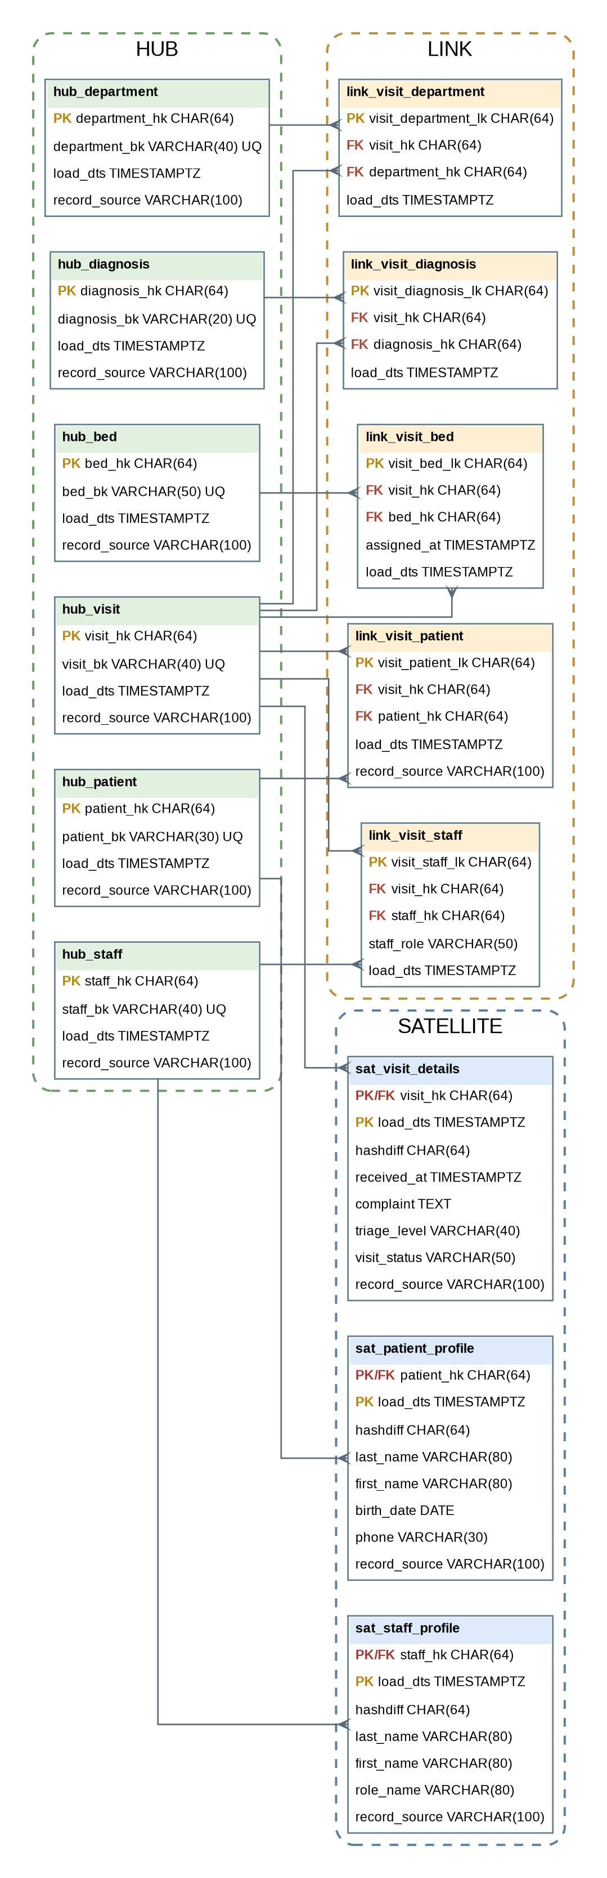
Data Vault отделяет бизнес-сущности (HUB), отношения между ними (LINK) и описательные атрибуты с историей изменений (SATELLITE).

Состав модели Data Vault (14 таблиц)
HUB (6): hub_patient, hub_staff, hub_department, hub_visit, hub_diagnosis, hub_bed — бизнес-ключи сущностей.
LINK (5): link_visit_patient, link_visit_staff, link_visit_department, link_visit_diagnosis, link_visit_bed — отношения между обращением и связанными сущностями.
SATELLITE (3): sat_patient_profile, sat_staff_profile, sat_visit_details — описательные атрибуты и история изменений.

SQL-код создания схемы Data Vault
CREATE TABLE hub_patient (
patient_hk CHAR(64) PRIMARY KEY,
patient_bk VARCHAR(30) NOT NULL UNIQUE, -- номер медицинской карты
load_dts TIMESTAMPTZ NOT NULL,
record_source VARCHAR(100) NOT NULL
);

CREATE TABLE hub_staff (
staff_hk CHAR(64) PRIMARY KEY,
staff_bk VARCHAR(40) NOT NULL UNIQUE, -- табельный номер
load_dts TIMESTAMPTZ NOT NULL,
record_source VARCHAR(100) NOT NULL
);

CREATE TABLE hub_department (
department_hk CHAR(64) PRIMARY KEY,
department_bk VARCHAR(40) NOT NULL UNIQUE, -- код подразделения
load_dts TIMESTAMPTZ NOT NULL,
record_source VARCHAR(100) NOT NULL
);

CREATE TABLE hub_visit (
visit_hk CHAR(64) PRIMARY KEY,
visit_bk VARCHAR(40) NOT NULL UNIQUE, -- номер обращения/случая
load_dts TIMESTAMPTZ NOT NULL,
record_source VARCHAR(100) NOT NULL
);

CREATE TABLE hub_diagnosis (
diagnosis_hk CHAR(64) PRIMARY KEY,
diagnosis_bk VARCHAR(20) NOT NULL UNIQUE, -- код диагноза
load_dts TIMESTAMPTZ NOT NULL,
record_source VARCHAR(100) NOT NULL
);

CREATE TABLE hub_bed (
bed_hk CHAR(64) PRIMARY KEY,
bed_bk VARCHAR(50) NOT NULL UNIQUE, -- код койки
load_dts TIMESTAMPTZ NOT NULL,
record_source VARCHAR(100) NOT NULL
);

CREATE TABLE link_visit_patient (
visit_patient_lk CHAR(64) PRIMARY KEY,
visit_hk CHAR(64) NOT NULL REFERENCES hub_visit(visit_hk),
patient_hk CHAR(64) NOT NULL REFERENCES hub_patient(patient_hk),
load_dts TIMESTAMPTZ NOT NULL,
record_source VARCHAR(100) NOT NULL,
UNIQUE (visit_hk, patient_hk)
);

CREATE TABLE link_visit_staff (
visit_staff_lk CHAR(64) PRIMARY KEY,
visit_hk CHAR(64) NOT NULL REFERENCES hub_visit(visit_hk),
staff_hk CHAR(64) NOT NULL REFERENCES hub_staff(staff_hk),
staff_role VARCHAR(50) NOT NULL, -- роль сотрудника в конкретном обращении
load_dts TIMESTAMPTZ NOT NULL,
record_source VARCHAR(100) NOT NULL,
UNIQUE (visit_hk, staff_hk, staff_role)
);

CREATE TABLE link_visit_department (
visit_department_lk CHAR(64) PRIMARY KEY,
visit_hk CHAR(64) NOT NULL REFERENCES hub_visit(visit_hk),
department_hk CHAR(64) NOT NULL REFERENCES hub_department(department_hk),
load_dts TIMESTAMPTZ NOT NULL,
record_source VARCHAR(100) NOT NULL,
UNIQUE (visit_hk, department_hk)
);

CREATE TABLE link_visit_diagnosis (
visit_diagnosis_lk CHAR(64) PRIMARY KEY,
visit_hk CHAR(64) NOT NULL REFERENCES hub_visit(visit_hk),
diagnosis_hk CHAR(64) NOT NULL REFERENCES hub_diagnosis(diagnosis_hk),
load_dts TIMESTAMPTZ NOT NULL,
record_source VARCHAR(100) NOT NULL,
UNIQUE (visit_hk, diagnosis_hk)
);

CREATE TABLE link_visit_bed (
visit_bed_lk CHAR(64) PRIMARY KEY,
visit_hk CHAR(64) NOT NULL REFERENCES hub_visit(visit_hk),
bed_hk CHAR(64) NOT NULL REFERENCES hub_bed(bed_hk),
assigned_at TIMESTAMPTZ NOT NULL, -- контекст связи/события
load_dts TIMESTAMPTZ NOT NULL,
record_source VARCHAR(100) NOT NULL,
UNIQUE (visit_hk, bed_hk, assigned_at)
);

CREATE TABLE sat_patient_profile (
patient_hk CHAR(64) NOT NULL REFERENCES hub_patient(patient_hk),
load_dts TIMESTAMPTZ NOT NULL,
load_end_dts TIMESTAMPTZ,
hashdiff CHAR(64) NOT NULL,
last_name VARCHAR(80) NOT NULL,
first_name VARCHAR(80) NOT NULL,
middle_name VARCHAR(80),
birth_date DATE,
sex VARCHAR(20),
phone VARCHAR(30),
record_source VARCHAR(100) NOT NULL,
PRIMARY KEY (patient_hk, load_dts),
CHECK (load_end_dts IS NULL OR load_end_dts > load_dts)
);

CREATE TABLE sat_staff_profile (
staff_hk CHAR(64) NOT NULL REFERENCES hub_staff(staff_hk),
load_dts TIMESTAMPTZ NOT NULL,
load_end_dts TIMESTAMPTZ,
hashdiff CHAR(64) NOT NULL,
last_name VARCHAR(80) NOT NULL,
first_name VARCHAR(80) NOT NULL,
role_name VARCHAR(80) NOT NULL,
phone VARCHAR(30),
record_source VARCHAR(100) NOT NULL,
PRIMARY KEY (staff_hk, load_dts),
CHECK (load_end_dts IS NULL OR load_end_dts > load_dts)
);
CREATE TABLE sat_visit_details (
visit_hk CHAR(64) NOT NULL REFERENCES hub_visit(visit_hk),
load_dts TIMESTAMPTZ NOT NULL,
load_end_dts TIMESTAMPTZ,
hashdiff CHAR(64) NOT NULL,
received_at TIMESTAMPTZ NOT NULL,
complaint TEXT NOT NULL,
triage_level VARCHAR(40),
visit_status VARCHAR(50),
arrival_method VARCHAR(60),
ended_at TIMESTAMPTZ,
discharge_outcome VARCHAR(80),
record_source VARCHAR(100) NOT NULL,
PRIMARY KEY (visit_hk, load_dts),
CHECK (load_end_dts IS NULL OR load_end_dts > load_dts),
CHECK (ended_at IS NULL OR ended_at >= received_at)
);

